PRESET MINIATURE REGULATOR FOR AIR

CartReg®

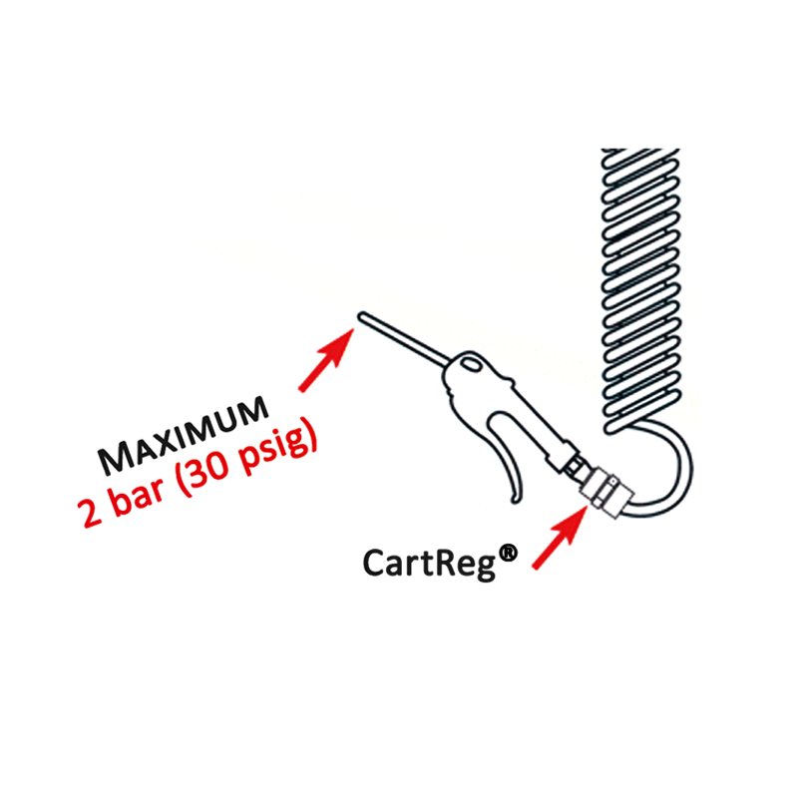
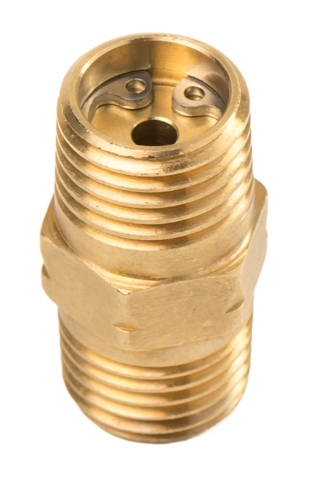

CartReg®
CartReg® - The economical and compact solution to various pneumatic applications. Engineered to comply with various international Health and Safety regulations on air blow guns, the preset CartReg® is the economical answer to keep in check the maximum pressure requirements. The preset miniature regulator is designed to meet OSHA (Occupational Safety & Health Administration, USA) and other safety agency requirements for 2 bar/30 psig maximum pressure for pneumatic air guns
The tamperproof the CartReg® can be easily mounted on any ¼” air blow gun and pneumatic tool and is an economical means to maintain the ideal pressure.

Your advantages

- Safety: protects personnel, machinery and plant by avoiding pressure surges
- Ensures optimal air tool efficiency by supplying a constant pre-set pressure
- Prevents compressed air waste – limits excessive compressed air consumption = reducing energy costs
- Easy assembly: can be integrated into any ¼” pneumatic tool
- Lightweight (15g) and compact (Hexagon 14 mm, length 24 mm)
- Locked to prevent pressure change – tamper proof
- Competitively priced
- Increases tool service life

Technical data |  | Applications
Max. inlet pressure: | 12 bar | Pneumatic air gun | Spray gun
Outlet pressure (preset): | 2… 8 bar | Workshop air lines | Pneumatic tools
Flow: | 350 Nl/min | General pneumatic appl.
Connection: | 1/4" BSP/NPT
Temperature range: | -20°C to 60°C
Weight: | 15g

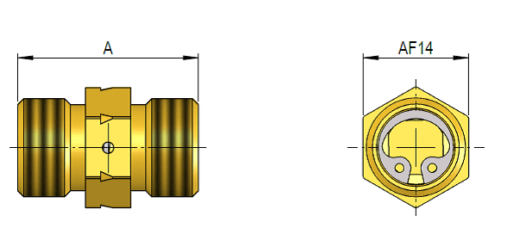

*Dimensions see datasheet on website – protect-air.com
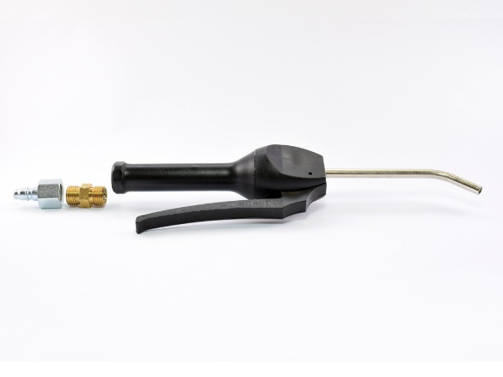
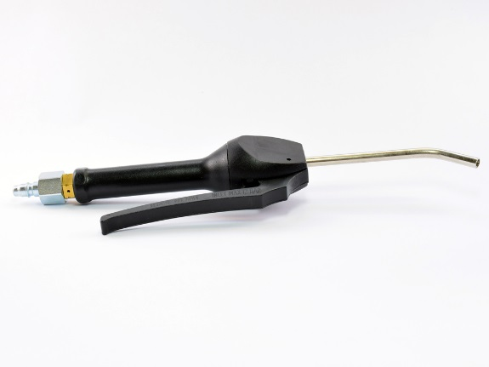
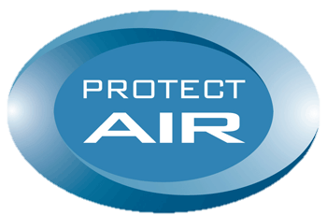
TRI-MATIC AG
Bösch 82
CH-6331 Hünenberg
Phone +41 (0)41 780 22 22
Email: info@tri-matic.ch
a brand of tri-matic

